An Introduction to Hidden Markov Models
James G. Schmolze

Date: Spring 2001
This summary is taken largely from ``An Introduction to Hidden Markov Models'' by Rabiner and Juang, IEEE ASSP Magazine, 3(1), January 1986, 4-16. Several additions have been made to in this paper.
We begin with a definition of a finite (non-hidden) Markov model (MM), which is intended to model certain types of stochastic processes.
- There is a finite set of states, , whose cardinality is , and the process being modeled is in exactly one state from at all times. Moreover, the process enjoys the Markov property, namely, that the history that led to the current state is irrelevant to the future behavior of the process. All that matters to future behavior is the current state.
- At each clock time, the process transitions to the next state (which may be the same as the previous state) based upon a transition probability distribution, , that depends only upon the previous state. Here is the probability that, when in state the process will transition next to state .
Clearly, a proper MM enjoys the property that the probability of transitioning from any given state to some next state is 1:
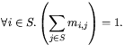
A finite hidden Markov model (HMM) is similar but the state information is hidden from the observer. (Some call an HMM a partially observable Markov process.) Moreover, there is a second stochastic process where the process produces an observation in each state.
- There is a finite set of possible observations, , whose cardinality is .
- There is a probability distribution of producing a given observation in each state. Here, is the probability of observing when the process is in state .
Clearly, a proper HMM enjoys the properties of MMs and also the fact that the probability of producing some observation in each state is 1:
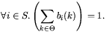
Moreover, we can view a MM as a special case of an HMM where and where the observation produced at each state is always the state itself, .
To complete our notation, we let be the initial state distribution. Here, represents the probability that the process begins in state where
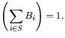
We use to refer to a particular HMM model, i.e., to a particular .
In what follows, we will work with respect to a specific sequence of observations that we call where is the length of the observation sequence and where each . We will often refer to the state sequence that produced and will call it .

Three Problems for HMMs
The three central problems that arise when working with HMMs follow.
- Given and , calculate , i.e., the probability that this model, , will produce the observation sequence . This is the evaluation problem: How likely is the model to have produced the observation sequence?
- Given and , choose a state sequence that is ``most likely'' to have produced from . This is the uncovering problem: Which sequence of state transitions is most likely to have led to this sequence of observations?
- Given and , how can we adjust the model parameters , , and to maximize . This is the training or learning problem: How can we take a set of observation sequences and learn the best values for the model parameters , , and ?

Solving Problem 1: The Evaluation Problem
One method is to use the law of total probability and condition on all possible state sequences, , of length : . The probability of a given sequence of states is simple: . The probability of a given observation sequence given a state sequence is also simple: . But the number of state sequences is exponential, so this is a poor method.
The standard approach is to use the forward-backward procedure, which takes advantage of the Markov property, namely that the path to a state is irrelevant to the future behavior of the process after being in that state. First we define
which is the probability of the process producing the first observations and of ending up in state at time . is easily calculated from .
To see this, we first apply the chain rule and get . Next we note that the law of total probability tells us that
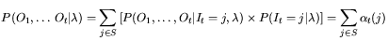
which becomes when we want the entire observation considered.
Moverover, is easily calculated iteratively:
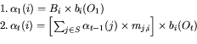
Notice that calculating requires on the order of calculations using as compared to requiring an exponential number of calculations.
represents the forward part, and represents the backward part. Let
which is the probability of the process being in state at time and also of producing the observations from time to .
We can also use to determine .
First we calculate :
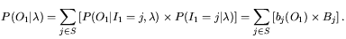
Next, we calculate :
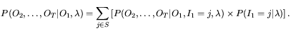
But once we condition on then we can ignore the conditions because knowing the obsevation produced at time gives us no more information once we know the state at time . Thus, we get the simplification
Putting these together, we get
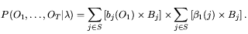
is also calculated easily.
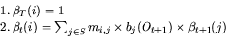
There are a few useful quantities that we can calculate with and that we now note.

Calculating
We define , which is the probability of the process being in state at time given and . Using the chain rule, we get , which means that
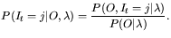
Using the chain rule again, we get
But we can simplify to thanks to the Markov property: Once we know that the observations are irrelevant. Thus, and
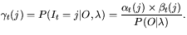
The probability was solved in the previous section on the evaluation problem.

Calculating
We define , which is the probability of the process being in state at time and in state at time , given and .
is the probability of the process being in state at time and in state at time given and . Using the chain rule (in reverse),
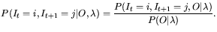
Using the chain rule on just the numerator, we get
The last term just above can be simplified because the observations are irrelevant given that . Moreover, this simplified version of this last term can be expanded with the chain rule.
Once again, we can simplify the last term just above by dropping the condition thanks to the Markov property. And we expand this simplified term one more time.
Finally, we can drop the condition in the last rerm thanks to Markov. We put all this together and get
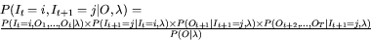
Thankfully, this simplifies to
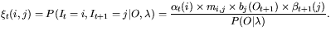
Note that is no more complex to calculate than is or .

Solving Problem 2: The Uncovering Problem
First we must identify a criteria upon which to maximize our selection of . We choose the following.
Then we can ``simply'' go through all possible such and pick the one with the maximum. Of course, this method is infeasible given the number of possible state sequences, so we need a more efficient method that takes advantage of the Markov property.
The Viterbi algorithm is the most popular solution to this. First, we rewrite our criteria using Bayes rule.
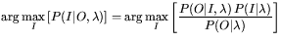
But we can discard the term since it will not affect the choice of . We are left with
The last equivalence comes from the chain rule.
Of course, we cannot examine all in practice so we introduce the quantity as follows. is the maximum probability of a length state sequence ending in state and of producing the first observations from .
It does not keep track of the state sequence that leads to this maximum; it just keeps track of the corresponding maximum probability. As we will soon see, can be calculated efficiently. Given , it is trivial to calculate the overall maximum probability:
takes advantage of the Markov property. is the maximum probability of the first observations and any length state sequence that ends in state . Thus, we can ignore the particular state sequence since states beyond depend only on and not on earlier states.
We can derive a recursive formula for as follows. We begin with:
We use the chain rule to pull out .
The latter term can be simplified since depends only on .
Next we extract .
The second term can be simplified since depends only on .
Thus,
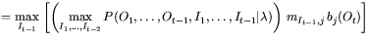
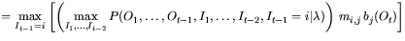
The base case is simple: .
But we are interested in the actual sequence that maximizes For this reason, we also define to recover the actual state sequence. is the state just before that leads to this maximum probability sequence. Taken together, we get the following.
- Initialization: 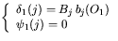
- Recursion: 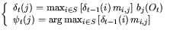
- Termination: 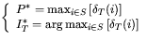
- Recovering the sequence:
Computing and requires on the order of operations, and recovering the most likely path requires additional steps.

Solving Problem 3: The Training Problem
Sadly, there is no known analytic method for determining a maximum likelihood model adjustment. Therefore, iterative techniques such as Baum-Welch or gradient descent techniques must be used. We examine only the Baum-Welch method.
Training is particularly difficult since we are given only a set of observation sequences that the process actually produced. We are not given the associated state transitions that occurred. Given those actual state transitions, the model adjustment would be simpler. But without those hidden variables, we must make an educated guess as to the state transitions that occurred.
If we sum over , we get the expected number of times that state is visited, or equivalently, the number of transitions made from state , if we exclude the last time point. Thus, we get the following.
the expected number of transitions made from state .
the expected number of transitions made from state to state .
We now have tools for counting state transitions for model adjustment.
The Baum-Welch reestimation formulas are as follows.
- 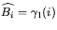, for .
- 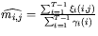
- 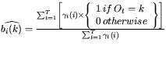In the numerator, we only include those such that (i.e., ) , where is the observation being examined.
(Yet to write: Adjustments to and when there are no observations in certain states.)
When you have a set of observation sequences, , we perform a similar estimation but over all the sequences at once. I will add superscripts to all the appropriate symbols to refer to the difference observation sequences.
- 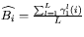
- 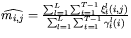
- 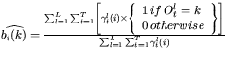
Here is the algorithm to train a model.
- Create an initial model . This can be done randomly, or by a mixture of knowledge of the process plus some randomness.
- Using the above, create from . Then create from .
- Repeat this until the process converges, or until you exhaust resources, yielding a final estimated model .

Jim Schmolze

